DIAGNOSIS: __________________________________________________________ ABO/Rh TYPE: _______________________

*Patient’s Name/ID Birth Date
*Date Collected *Date Submitted * Sex
*Hospital/Facility
*Physician Requesting Test(s)
Information on test methods, performance specifications and interpretation are available on request.
*CLIA Required Information, CFR 493.1241

TRANSFUSION HISTORY: Number of transfusions received: Platelets ___________________ Red Cells ____________________
DATE OF MOST RECENT TRANSFUSION: Platelets ___________________ Red Cells ____________________
PREGNANCY: Is patient now pregnant? ______________ Gravida ______________ Para _______________________
DRUG HISTORY: List or attach all medications patient is or has recently received: __

□ 3980 Platelet Antibody Screen
Requires 7-10 mL ACD Whole Blood or 2 mL ACD plasma
□ 3980 Platelet Antibody Screen using ELISA Assay – PakPlus
Requires 7 mL ACD Whole Blood or 2 mL ACD plasma AND 7-10 mL clotted whole blood or 2 mL serum
□ 3982 Platelet-Bound IgG
Current Platelet Count _______________________________ (Required)
Requires 7-10 mL ACD whole blood < 24 hours old, unrefrigerated.
If platelet count is < 50,000, call for instructions. Test requires minimum platelet count of 10,000.
□ 3980 Investigate Autoimmune Thrombocytopenia
3982 Current Platelet count _________________________ (Required)
Sample Requirements: See Platelet Antibody Screen and Platelet – Bound IgG
□ 3984 Platelet Crossmatch
Number of units requested: ______________________ Frequency: _______________________
Special requirements: CMV Neg Other: _________________________
Are Non ABO type-specific platelets Acceptable? Yes: No:_____
□ 3983 Investigate Neonatal Immune Thrombocytopenia
Requires 14-20 mL Maternal ACD whole blood, < 24 hours, unrefrigerated AND 7-10 mL clotted whole blood or 2 mL serum if PakPlus testing needed
Current Platelet Count _______________________________ (Required)
Requires 7-10 mL Paternal ACD whole blood, < 24 hours, unrefrigerated.
Current Platelet Count _______________________________ (Required)
Samples from the infant are not required.
□ 3990 Investigate Posttransfusion Purpura
Current Platelet Count _______________________________ (Required)
Requires 7-10 mL ACD whole blood < 24 hours, unrefrigerated AND 7-10 mL clotted whole blood or 2 mL serum if PakPlus testing needed. If platelet count is < 50,000, call for instructions.

□ Other__________________________________________________________________________________________________

Date: Personnel authorized to request tests/receive results: ___________________________
FAX: Telephone:_____________________________________

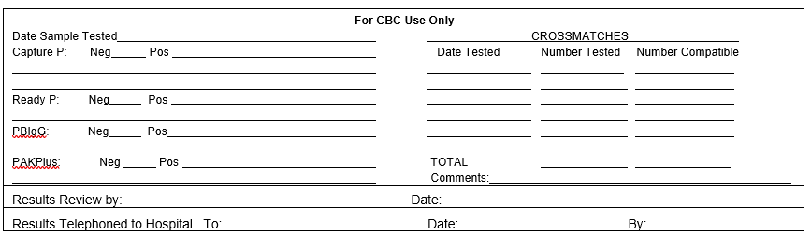

Send to:

Community Blood Center
Platelet Antibody Lab
4040 Main, Kansas City, MO 64111

From: ___________________________

Ship: STAT ASAP Routine

Test: STAT ASAP Routine

Please call IRL at 816-968-4053 prior to sending sample.

